**MY SQL**

NAME:SHRAVANI DESAI

AF ID: AF04953349

1.CREATE TABLE: CREATE TABLE employees ( emp_id INT PRIMARY KEY, name VARCHAR(100) NOT NULL, department VARCHAR(50), salary DOUBLE, join_date DATE

);

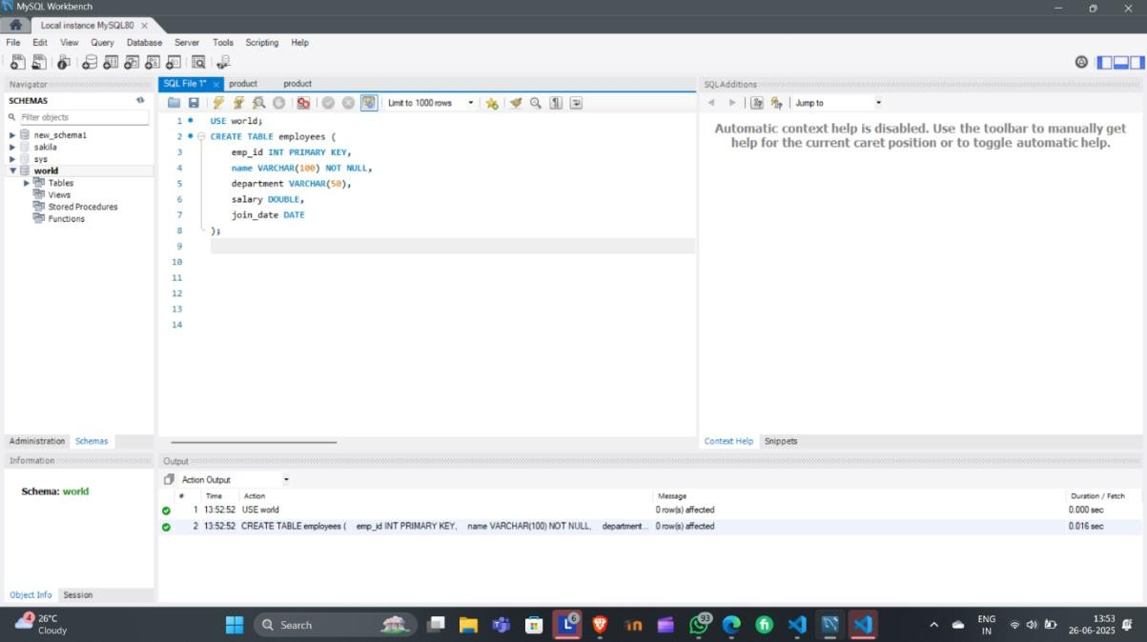

INSERT :

INSERT INTO employees (emp_id, name, department, salary, join_date) VALUES

(101, 'John Doe', 'HR', 45000, '2021-06-15'),

(102, 'Jane Smith', 'IT', 75000, '2020-01-10'),

(103, 'Alice Johnson', 'Finance', 60000, '2019-08-23'),

(104, 'Bob Brown', 'IT', 80000, '2022-03-01'),

(105, 'Eve Davis', 'Marketing', 55000, '2021-11-05');

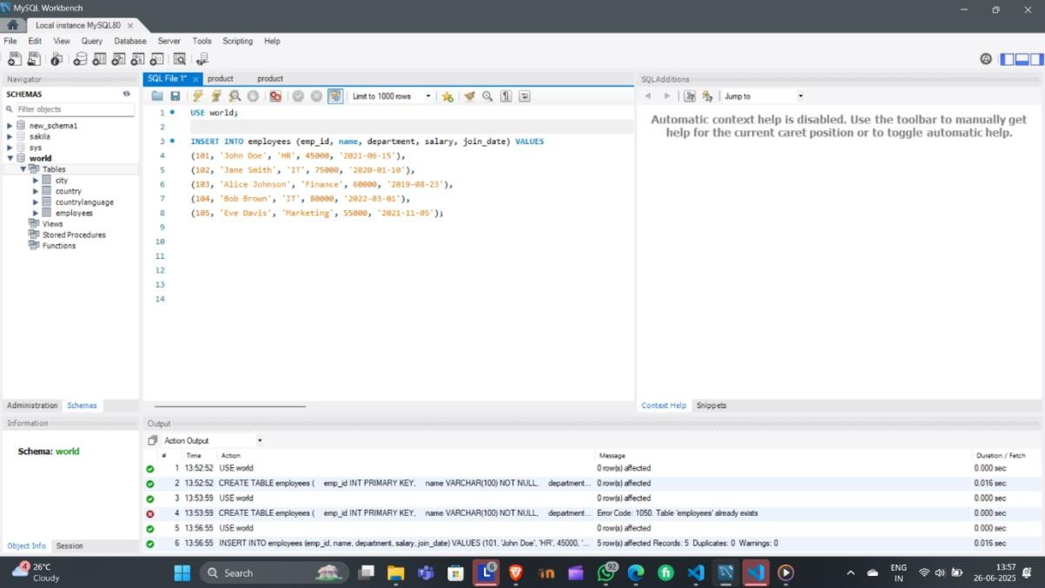

SELECT QUERY :

-- View all employee data

SELECT * FROM employees;

-- View only names and departments

SELECT name, department FROM employees;

-- View employees in the IT department

SELECT * FROM employees

WHERE department = 'IT';

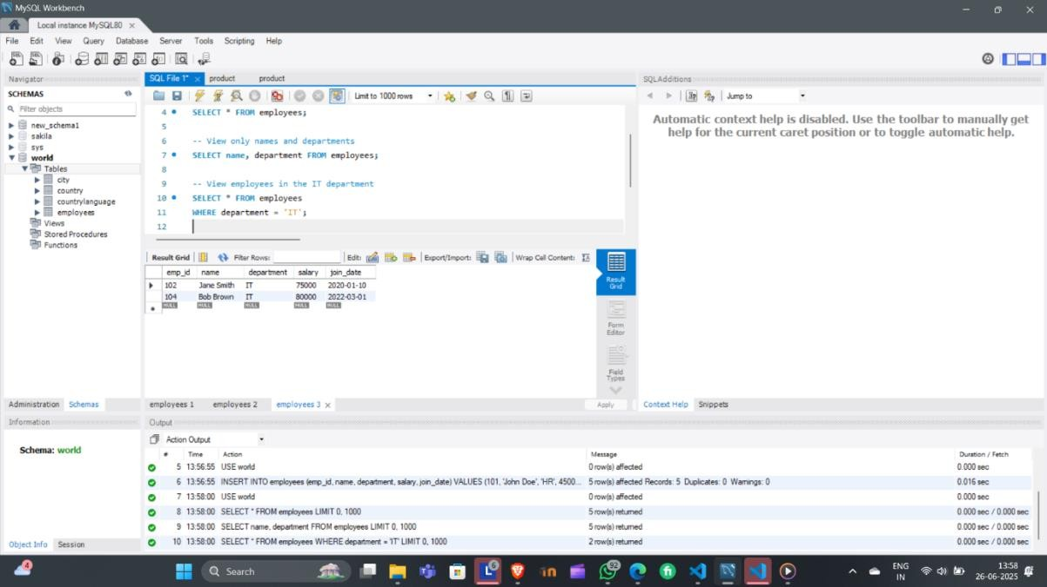

AND,IN BETWEEN &LIKE:

SELECT * FROM employees

WHERE department = 'IT' AND salary > 75000;

SELECT * FROM employees

WHERE department IN ('IT', 'Finance');

SELECT * FROM employees

WHERE salary BETWEEN 50000 AND 70000;

SELECT * FROM employees

WHERE name LIKE 'J%'; -- Names starting with J

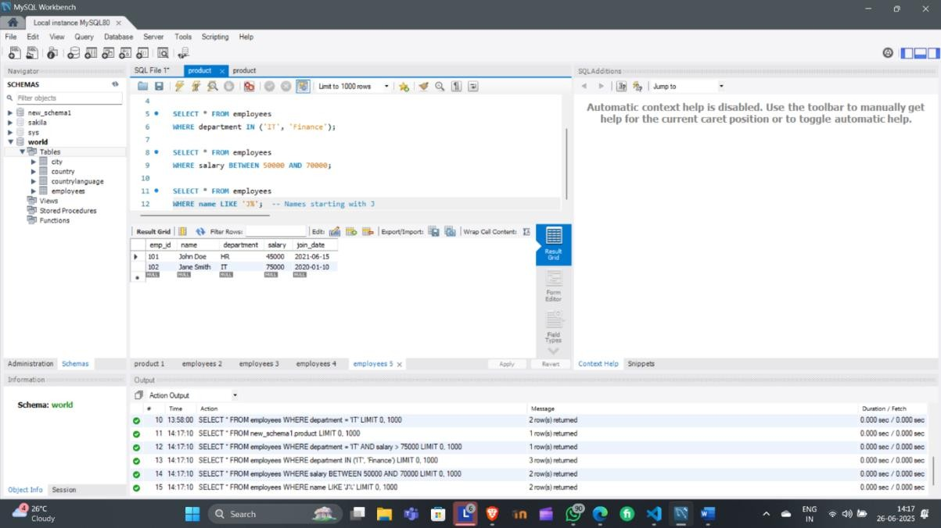

CLAUSE- ORDER BY WHERE,HAVING & UPDATE QUERY:

SELECT * FROM employees

ORDER BY salary DESC;

UPDATE QUERY

UPDATE employees

SET salary = 82000

WHERE emp_id = 104;

DELETE FROM employees

WHERE emp_id = 105;

SELECT department, AVG(salary) AS avg_salary

FROM employees

GROUP BY department;

SELECT department, COUNT(*) AS emp_count

FROM employees

GROUP BY department

HAVING COUNT(*) > 1;

